**Chapter 6- Commercial liability insurances**

1. **Liability insurance**

A1- Operative clause

Are clause(s) that describe(s) the standard scope of cover of each section of an I policy.

A1a- Legal liability

Policies cover the insured’s legal liability for damages by PIAB, the court or agreed out of court. Damages may be awarded for personal injuries, damage to property or for some types of financial loss.

A1b- Legal costs & expenses

Policies cover the insured’s legal liability for the plaintiff’s (3rd party) costs & expenses, as well as defence costs. This is a very important element of cover, even if a PH is not responsible for the incident that gave rise to a claim, they may still incur expensive cots in defending a legal action.

A1c- Definition of the business

If the business description is inaccurate, or omits an important aspect of the insured’s activities, this could have serious consequences in the event of a claim.

A1d- Geographical/territorial and jurisdiction limits

Operative clauses will usually state both the geographical and jurisdiction limits of a policy. The difference between these is as follows:

* Geographical- these state the areas where cover will apply. For example, an employer’s liability policy typically covers the insured’s for injuries to employees in the ROI, NI, GB, IOM and the Channel Islands, or temporarily working outside these territories.
* Jurisdiction limit- this is clause stating that claims must be brought against the PH in a specified territory or under Irish law. This means that although a policy might have a worldwide geographical limit, the insurer will only provide indemnity for claims brought against the PH in the named jurisdiction.

A1e- Limits of indemnity

Unlike property and BII, liability insurances do not have sums insured. Instead, they are subject to limits of indemnity which are chosen by the client usually.

A2- Policy triggers and basis of cover

Different stages of a liability event may trigger a claim under the policy. The main triggers are:

* The initial act, usually negligence, but in some cases another legal wrong
* The actual injury, loss, or damage resulting from the act
* The manifestation of the injury, loss or damage
* The aggrieved or injured party’s awareness of the injury, loss or damage
* Notification of the claim to the PH
* Notification of the claim to the insurer

In many situations the first 4 points happen almost simultaneously.

A2a- ‘Occurrence’ basis

This means liability policy cover that is triggered when the incident occurs (which could be over a period of time). Employer’s liability wordings typically refer to ‘death, bodily injury, illness or disease **caused** during the period of I’.

Public & products liability wordings often refer to ‘death, bodily injury, illness, disease and damage to property **occurring** during the period of I’.

A2b- ‘Claims made’ basis

This means liability policy cover that is triggered when the 3rd party (claimant) makes a claim against the PH and must be made during the period of I. The most common class of liability cover underwritten on this basis is professional indemnity I (which is I cover in respect of liability arising from breach of professional duty (by the PH or their predecessors)). Policies usually have a retroactive date (this is the date shown on the schedule of a ‘claims made’ policy. There is no cover for claims arising from acts/events that happened prior to this date).

A3- The package of covers

Combined employers liability, public liability and products liability policies are very common. Many insurers do not wish to insure one of these covers on a stand-alone basis, but are prepared to provide cover for a combined liability arrangement.

* Employers liability (cover)- I to cover the legal liability of the insured to any person who is under a contract of service or apprenticeship
* Public liability (cover)- I that covers injury or death to anyone on or around the PHs property
* Public liability (cover)- I for all providers of goods- whether manufacturers, intermediaries or retailers- against claims arising out of the use, handling or consumption of a product

1. **Employers liability insurance**

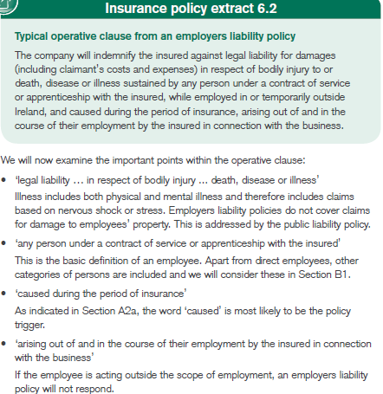

B1- Definition of an employee

The policy definition of an employee is: ‘any person while working for the insured in connection with the business who is under a contract of service or apprenticeship with the insured’. Insurers are keen to define the scope of the term ‘employee’ to make sure that it also includes some categories of persons not directly employed by the PH. Categories include:

* Labour masters, labour only sub-contractors (a category of worker contracted for ‘labour only’ (usually without their own liability I) and treated as an employee under a liability I policy) and persons employed or supplied by them
* Self-employed persons
* Persons hired or borrowed by the insured under an agreement where the person is considered to be employed by the insured
* Persons engaged in any training, educational or work experience programme

B2- Cover considerations

When arranging employer’s liability cover, the adviser must work with the client to prepare an accurate wages declaration. This figure is the exposure measure used for setting the premium. Policies are normally arranged on a declaration basis. The initial premium is adjusted at the end of the period of I, when exact wage figures are known and declared to the insurer. When rating a risk insurers also categorise employees according to the nature of their work.

* Clerical staff
* Manual/working directors
* Manual work away from the premises
* Drivers
* All other employees

It is also important to establish whether any employees are working outside of Ireland, and if so, how temporary or otherwise their employment is.

B2a- Indemnity to principal

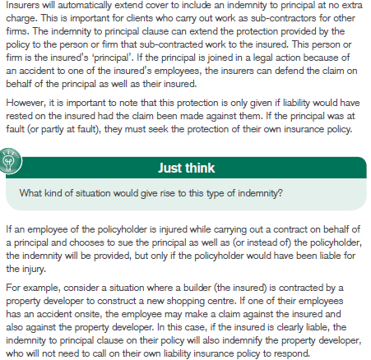

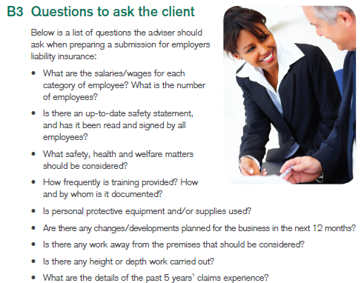

B4- Employment practices liability insurance

Standard employer’s liability cover is restricted to claims that involve bodily injury/disease. This policy, however, protects the client against employment-related litigation e.g. sexual harassment, discrimination or wrongful dismissal.

1. **Public liability insurance**

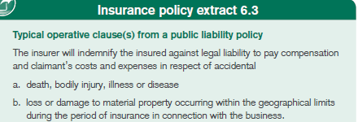

Some policies also cover liability to p[ay compensation for financial loss caused by nuisance, trespass, obstruction or interference with rights of way, light, air or water, wrongful arrest and false imprisonment, where the wrong is committed ‘accidentally’.

Some of the important points of the operative clause include:

* Legal liability- in respect of accidental (a) death, bodily injury, illness or disease (b) loss of or damage to material property. This includes loss of earnings/ profit resulting from unintended injury or damage.
* Occurring during the period of I- the word ‘occurring’ is the policy trigger
* Policy excess- an excess often applies to 3rd party property damage claims

C1- The nature of the exposure

There are a number of ways to rate a public liability risk. Insurers usually base their rating on turnover, as it is a fair indication of the risk relative to the size of the business.

C2- Policy cover considerations and exclusions

Limits of indemnity vary but are usually between €1.3m and €6.5m in respect of any 1 claim. 2 standard exclusions as follows:

C2a- Tool of trade risk

Liabilities under the **Road Traffic Acts 1961 & 2010** for any mechanically-propelled road vehicle must be covered under a motor I policy

C2b- Lifts, escalators and steam boilers

Some insurers will cover these under their public liability policies, while others will have a specific exclusion. The risk may also be insured under a separate engineering policy.

C2c Advice, treatment or professional risks

Where there is an advice risk that is separate from the provision of a product or service, this should always be insured separately under a professional indemnity policy. Some small retail package policies may extend the public liability policy to include treatment risk e.g. hairdressers and beauty salons.

C3- Policy extensions to consider

C3a- Indemnity to principal

Similar to the cover provided under an employer’s liability policy (section B2b), the public liability policy may provide an automatic extension for indemnity to a principal. It will provide cover for the principal as a result of work carried out by the PH, provided that the liability would have been covered if the claim had been made directly against the PH

C3b- Contractual liability

As with an employer’s liability policy, the standard policy wording will generally exclude any liability assumed (accepted) under contract that would not apply otherwise. In certain situations the cover may be extended, if required, at an additional cost

C3c- Cross liabilities

If there is more than 1 insured, the cover will apply separately to each 1 as if a separate policy had been issued to each, but the total limit of indemnity will remain the same

C3d- Safety, Health and Welfare at Work Act 2005

This is similar to the extension in an employer’s liability policy

C3e- Motor contingent liability

This is an extension to a public liability policy providing indemnity to an employer when an employee uses their own car on the firm’s business. Cover is available as a stand-alone policy or as an extension of a motor fleet policy or a public liability policy. This policy will operate only if the relevant motor policy fails

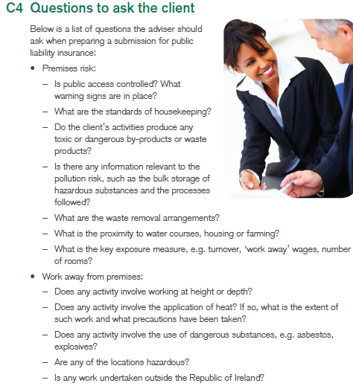

1. **Products liability insurance**

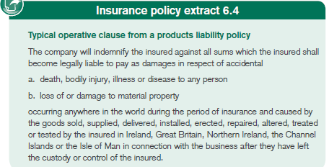

There are some similarities between the operative clauses for products liability and public liability I. Specific points to note in relation to products liability cover are:

* ‘occurring anywhere in the world’- many policies provide worldwide cover, regardless of where the damage has arisen and would include liability resulting from any products in another country without the insured’s awareness of it
* ‘occurring...during the period of I’- this is an ‘occurrence’ basis. Injury/damage must occur during the period of I (not necessarily when the product was supplied)
* ‘caused by the goods sold, supplied, delivered, installed, erected, repaired, altered, treated or tested by the insured’
* ‘in Ireland, GB, NI, the Chanel Islands or the IOM’
* ‘after they have left the custody or control of the insured’
* Limits of indemnity- 2 limits of indemnity apply; a max limit known as an aggregate limit of indemnity (a max limit of indemnity for any 1 period of I, regardless of the number of claims), for all claims arising under the policy in any 1 period of I and a specific limit applying to any 1 claim. This differs from both employers and public liability cover where the limit of indemnity applies only to any 1 claim and policies provides unlimited indemnity for all claims arising in any 1 period of I
* Legal costs & expenses- insurers are liable only for expenses incurred with their consent. However, this would be normal practice, as the insurer will want to control the whole process. The basis used is ‘payable in addition to the limit of indemnity unless it is ‘cost inclusive’- this is a type of indemnity provided by liability I where cover for defence costs is included in the limit of indemnity
* Policy exclusions- typical policy exclusions apply, e.g. replacement/guarantee of a product, product recall, exports to the US/Canada (unless agreed in advance of cover)

D1- Nature of exposure

The main exposure the PH faces is due to their obligation under the Liability for Defective Products Act 1991 & the Sale of Goods and Supply of Services Act 1980. When setting premiums, insurers apply different rates to the turnover generated by different categories of products- low hazard like paper/cardboard are rated lower to pharmaceutical products. Rates will also depend if they export to North America, given the high value of claims awarded.

D2- Policy cover considerations

Same limits are available for products liability policies €1.3m – €6.5m and a PH will generally opt for the same limit under each section. However, the adviser should inform the PH that this limit will also act as an aggregate figure for any 1 period of I. This is because insurers are concerned that similar defect problems will result in 100’s of claims i.e. faulty batch of products or food poisoning.

D2a Extensions available

Some insurers will offer extensions for products liability cover, however some specific extensions of cover are only offered by specialists markets. These extensions include:

* Contractual liability- normally only considered if contracts are seen and approved by the insurer
* Product recall (specialist market)
* Cross liabilities
* Efficacy risk(limited specialist market) (the risk of failure of a product to fulfil its intended purpose or function

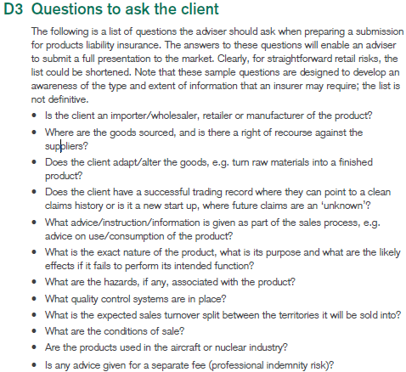

1. **Directors and officers liability insurance**

This is I cover to protect individuals when they are held personally liable for their actions as a director or officer of a company under particular legislation. Potential claims against company directors include legal actions brought by:

* Shareholders- for error resulting in the under-performance of the firm financially
* Creditors- for breach of duty resulting in the firm being placed in receivership
* Competitors- for a misleading statement or libellous comment
* Employees- for breach of employment legislation
* Government bodies- for breach of company legislation
* Trustees- for breach of duty in handling pension funds

Cover excludes fraud or dishonesty on the part of directors, fines, penalties and punitive damages (damages awarded by a court designed to punish the defendant rather than compensate for the loss suffered by the plaintiff).

D&O is written on a ‘claims-made’ basis. The policy has 2 parts which indemnify:

* The directors as individuals in a personal capacity
* The company

A ‘nil’ excess normally applies to claims taken against directors personally. Insurers generally rate a D&O liability risk on reviewing:

* The limit requested
* An audited set of financial accounts for a company
* The completed proposal form

E1- Questions to ask the client

* The company, its history and business description- any recent merger of acquisition activity (or future plan) is also important
* Finance and ownership- this includes details of who owns the company and how it is financed, as well as details of its financial strength
* Territory- if the co trades in the US, or has US subsidiaries or a US parent co, then it may be exposed to the US legal environment
* The directors- info on the co board and its composition- the individuals themselves- is required as well as any systems in place for training and appraising directors

1. **Professional indemnity insurance**

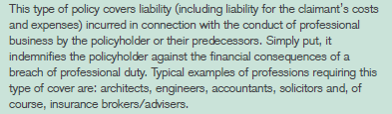

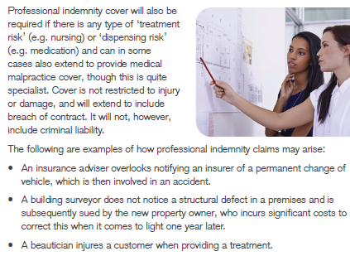

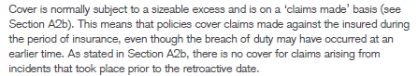

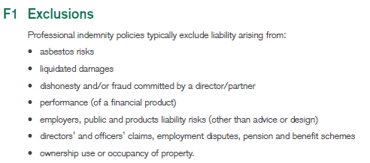

F2- Questions to ask client

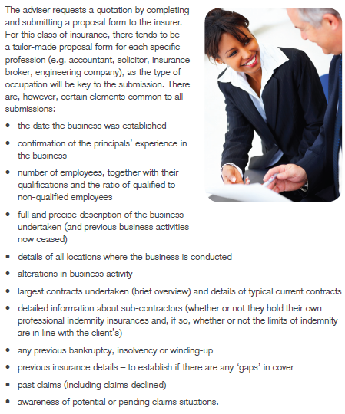

1. **Commercial legal expense insurance**

This is not a liability cover, but should be considered in association with liability insurances. Liability and motor I policies provide cover in situations where a PH has allegedly caused hard to a 3rd party or damage to their property. CLE cover is often included as standard within ‘package’ and ‘combined’ policies. Cover is available under these policies for the legal and other costs incurred in the defence of a claim against the PH.

Cover is restricted to certain types of claim as listed in the policy schedule. Cover does not include legal action costs for which indemnity is recoverable elsewhere e.g. employers liability or public liability policies. Other legal costs may be incurred in different business contexts e.g. cases arising from:

* Safety, health and welfare at work legislation
* Data protection legislation
* Discrimination legislation
* The recovery of uninsured losses from at-fault third parties

The last one is catered for under a specialist motor legal expenses cover when it relates to a motor accident.

The main policy provisos are that the insurer will **only** fund:

* A legal action where there is a reasonable prospect of success for the PH
* Legal costs incurred with the insurer’s prior consent

**Chapter 7- The claims process**

1. **The claims process**

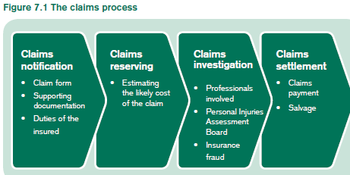

1. **The role of the intermediary**

B1- Client relationship

Sometimes an intermediary may wish to be involved in the claims process for the following reasons:

* Support client relationship and demonstrate their added value
* Bring their expertise and experience to bear for both the clients and insurers benefit
* Be fully appraised of any situation in which a claim will be declined or not fully met
* Assist the insurer in complex situations to clarify matters for both insurer and client
* Assist in recovering claims for uninsured losses

B2- Type of claim

The extents of the intermediary’s role will vary depending on the type of claim. It would be unusual for them to be involved in claims for 3rd parties. Whereas they will play a more significant role in property or own damage motor claims.

B3- Delegated authority

Occasionally, an intermediary may have authority to settle claims on behalf of the insurer. In this situation, all of the insurer’s regulatory obligations will fall in the on the intermediary.

1. **Claims notification**

The policy may specify a time limit for notifying a claim to the insurer. The claims notifications conditions in a policy are designed to ensure:

* Early investigation in order to minimise the cost
* Early appointment of loss adjusters or solicitors where appropriate
* Detailed evidence is not lost through delay
* The insurer reports certain losses to reinsurers within the required deadlines

The insurer also has regulatory obligations at the notification stage. For example where a claim form is needed, the Consumer Protection Code requires the insurer to issue this doc within **5 business days.**

C1- Claim forms

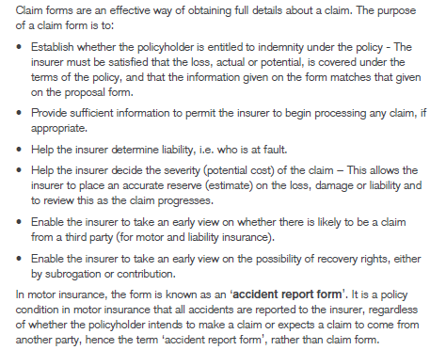

C2- Other supporting documentation

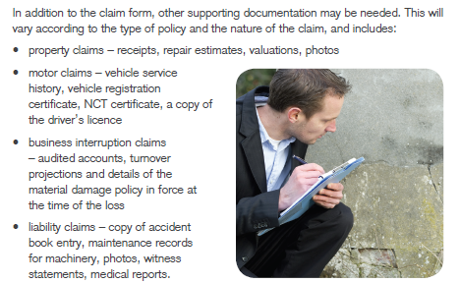

C3- Insurer’s advise to the policyholder

* Take immediate action to minimise the loss
* Keep any damaged items, as the insurer may need to inspect them
* Notify Gardai immediately about loss/damage
* Notify fire brigade immediately of any fire/explosion
* Not admit liability, offer or negotiate any payment of a 3rd party, unless the insurer approves this

Depending on the type of claim, the insurer will need to take specific action when notified of an incident, e.g., the insurer may

* Arrange for towing, of damaged vehicles to the nearest repairer
* Advise of any requirement to approach the PIAB
* Advise the PH to take steps to prevent further damage/loss
* Advise that it will appoint a loss adjustor

C4- Checking the claim information

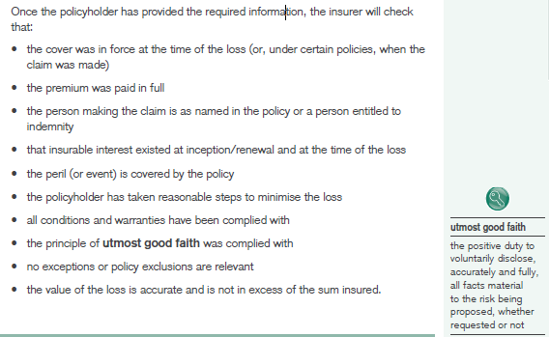

If it appears that there may have been a breach of warranty, the insurer will arrange for a detailed investigation.

1. **Claims reserving**

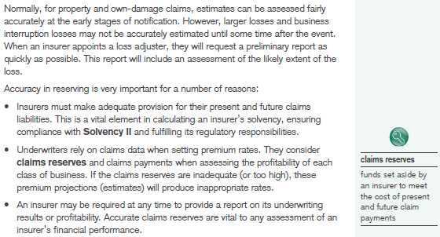

1. **Claims investigation**

E1- the claims handler

The role of the claims handler is to:

* Deal with claims quickly and fairly
* Distinguish between genuine and fraudulent claims
* Assess the likely cost of a claim in order to decide on a reserve
* Settle claims efficiently and with minimum cost

A claims handler will normally oversee all aspects of the investigation. Reasons why they cannot may be because:

* The claim is too large or complex
* The circumstances or full extent of an injury is unclear
* The PHs claim history is of concern
* Fraud is suspected

E2- The claims investigator

An individual who is skilled, experienced and qualified to investigate the circumstances of individual claims on behalf of an insurer.

E3- Loss adjusters

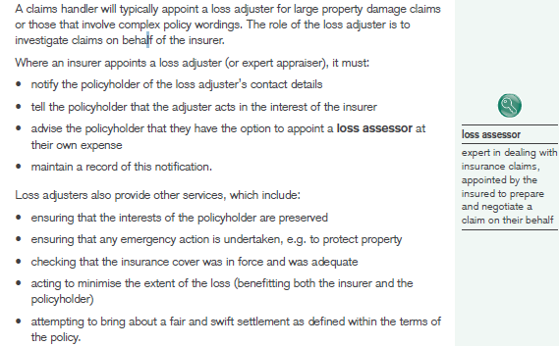

E4- Loss assessors

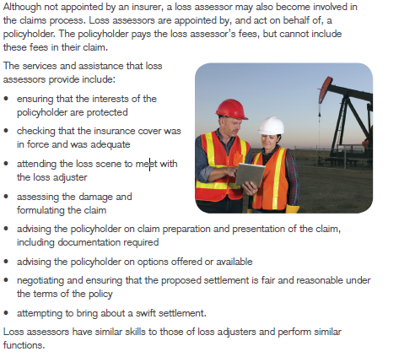

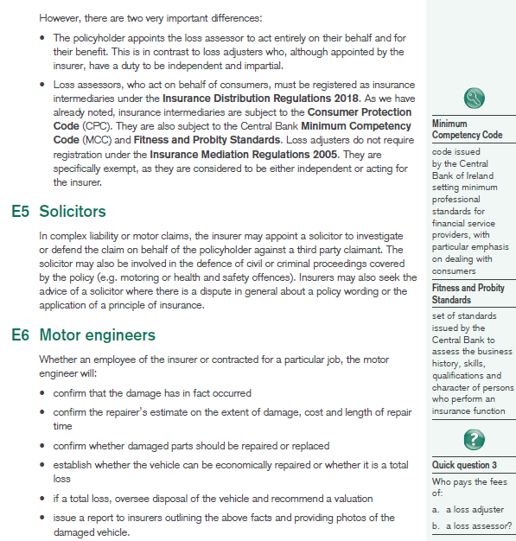

E7- Special considerations for third party claims

When a claim involves injury to a 3rd party or damage to their property, the insurer will investigate the circumstances of the incident and the allegations of negligence against its PH

E7a- Personal Injuries Assessment Board (PIAB)

The aim of the PIAB is to reduce costs- especially legal costs and admin fees for personal injury claims.

Book of Quantum- is a general guide to the amounts that may be awarded to a claimant; legislation requires PIAB to have regard to the BoQ when assessing claim values. PIAB will not make an assessment if:

* The injury is purely psychological
* There is insufficient precedent
* The claim arose from medical negligence

When investigating PI claims, insurers must take into account PIAB procedures and timescales. Of particular importance is the 90-day (calendar days) deadline for the insurer to confirm whether or not they consent to assessment by PIAB. If the insurer disputes liability and refuses to agree to an assessment, PIAB will issue the claimant with an ‘authorisation’ which will allow them to pursue their action through the courts system.

E8- Insurance fraud

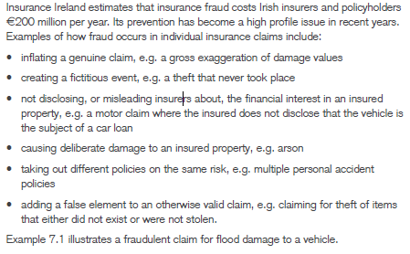

All advisers need to be aware of fraud indicators, once a defined number are present a full investigation should commence. Examples of fraud indicators include:

* Frequent change of insurers to avoid single insurer gathering too much info
* Unusual changes to cover- adding accidental cover to household mid-term
* Unclear ownership of goods
* Financial difficulties- this is difficult to establish
* Excessive pressure to settle, or willing to settle for a smaller sum
* Suspicious documentation

E8a- Fraud prevention and detection

A number of industry initiatives have been designed, including

* Insurance Ireland- in cooperation with Gardai
* Insurance confidential- set up by II- a hotline to allow members of public report cases of suspected fraud
* InsuranceLink- allows insurers to cross-reference individual claims with other insurers

1. **Claims settlement**

F1- Settlement methods

F1a- Payment of money

This is the most common form of payment. Payment to the claimant must be made within 10 business days of their agreement to accept the settlement offer.

F1b- Payment for repairs

If an insurer decides to settle this way, it must notify the claimant in advance of the scope of work and its costs. The insurer must ensure that the work is competed to satisfactory standard.

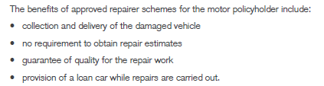

F1c- Replacement

This is usually more common in personal than in commercial insurances.

F1d- Reinstatement

Property insurance policies normally also give an insurer the right to settle a claim by reinstating a property that has been destroyed or extensively damaged.

F2- Salvage

When a motor or commercial property claim is settled on a total-loss basis, an insurer is entitled to the value of the salvage.